UI will look like this:

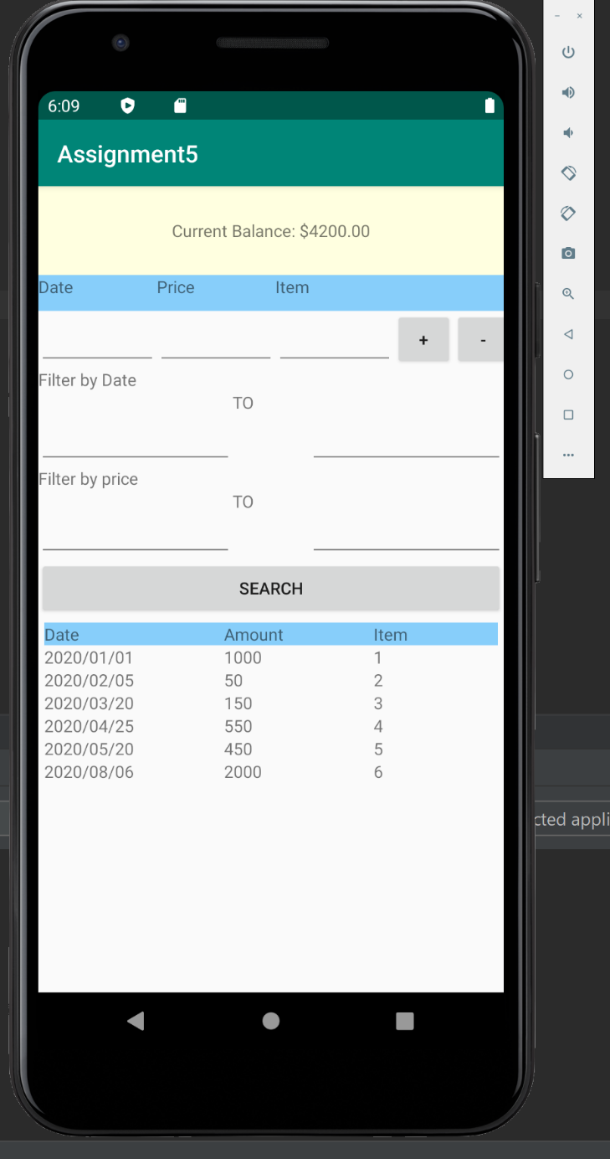

The user will have the option to be able to add deposits or withdrawals by using the + or – button at the top after entering their information. Then the item will appear in the table at the bottom of the screen. Once several items have been entered, the user will be able to search the entered items by price, date entered, or both.